Title Page, Declaration, Abstract, Acknowledgements, Table of Contents.
List of Figures
List of Tables
Abbreviations

Introduction (1)
In the modern digital age, day-to-day life has become completely intertwined with the internet, which now serves as a global hub for all things pertaining to communication, finance, information and much more, resulting in most individuals and organizations relying heavily on it for their daily social or productive activities such as social media, banking, education, entertainment, healthcare, etc. However, this evolution in technology has also seen an evolution in cyber threats from malicious actors who seek to exploit online vulnerabilities to compromise privacy and integrity. They utilize several techniques of cybercrime to carry this out, thus disrupting the daily flow of life online.
Background and Motivation (1.1)
Phishing is a common term used in the digital age that is loosely derived from the process of ‘luring’ in the fishing activity. [1] describes it as the practice of deceiving users by masquerading malicious sources as legitimate. These sources, through which such a scam is usually carried out include websites, emails, SMS, etc. The attacker masks these websites and emails to impersonate legitimate companies such as government portals, medical sites, banks and finance websites and more. The main purpose of this cyberattack is to extract personal sensitive information from victims like passwords which are then used by the attacker for their own benefit. In certain cases, these phishing attacks deceive victims into unknowingly installing malware and viruses onto their computers making them vulnerable to other forms of cyber-attacks.
Over the years, different forms of phishing attacks have been developed by hackers [2]. The common denominator in these attacks is the luring of victims to access a phishing site. Spoofing Emails are malicious emails sent by attackers that are written similarly to their legitimate counterparts with forged sender’s address. Spear-Phishing is a form of Spoofing that targets specific individuals and organizations. Whaling is its subset that involves high ranking targets for obtaining classified information. SMiShing is an attack that uses SMS mobile services instead of emails while Vishing sees the attacker, pretending to be a high-ranking individual, scams the victim through a phone call.
According to [3], the main aspect of developing a phishing website, email, etc. is to make it resemble the official counterpart as close as possible using official logos and layouts so that the victim does not question its authenticity. There is however, one surefire way to tell whether a website is legitimate or not, and that is by its URL. A Uniform Resource Locator (URL) is the unique defining address of a specific resource available on the internet. Any malicious website seeking to impersonate its legitimate counterpart will have an irregular URL that will give away its legitimacy when examined by experienced internet users. An analysis by [4] shows that these URLs would include unnecessary special characters (e.g., @, /, -), or misspelled domain names (e.g., gooogle, fac3bo0k).
Unfortunately, due to the fast-moving lives of common folk, most people tend to not notice the irregular URLs. They’re more focused on completing their tasks, which makes them extremely vulnerable to phishing attacks. [18] showcases that during the Covid-19 pandemic, there was a huge surge in phishing attacks with its frequency increasing by 4 times during this period. [16] tells us that these phishing attacks used covid related domains to lure people by allegedly providing methods to stop the outbreak. According to the Anti-Phishing Working Group (APWG), their Phishing Activity Trends Report for 2025 [36] reveals that over 2 million phishing attacks have occurred in the first half of 2025 with the financial sector being frequently targeted.
As seen in Section 2, the integration of temporal dependencies modeling combined with lexical patterns extraction in phishing detection remains relatively unexplored. Though CNNs are able to capture a URL’s lexical features, it is limited in learning temporal features. The proposed 1D-CNN-BiGRU hybrid framework addresses this limitation by having the capability of capturing forward and backward temporal dependencies of the extracted lexical features, thus allowing for detecting deeper relations and patterns of the URL’s structure.
Aim and Objectives (1.2)
Aim: To design, implement and evaluate a hybrid deep learning framework for the purpose of detecting phishing websites and assessing whether the hybrid model outperforms traditional ML based systems in terms of accuracy on standard phishing datasets.
Objectives:
- Acquire and preprocess publicly available phishing datasets.
- Utilize a 1-Dimensional Convolutional Neural Network (1D-CNN) for extracting lexical features and patterns.
- Utilize a Bidirectional Gated Recurrent Unit (BiGRU) to extract the temporal features and sequential dependencies.
- Develop a hybrid deep learning framework, combining the 1D-CNN and BiGRU models.
- Train the hybrid framework on the preprocessed datasets.
- Evaluate the performance of the framework by means of standard empirical metrics.
- Compare the evaluated performance of proposed framework against existing ML-based phishing detection models.
Organisation (1.3)
The rest of this dissertation shall follow an organized structure. Section 2 presents the Background Research, where we shall be examining previous studies and research conducted. Section 3 shall cover the detailed description of the proposed hybrid framework with Section 4 covering the necessary requirements analysis for developing this framework. Section 5 will talk about the evaluation of the framework: the datasets on which it will be tested and the metrics on which it will be evaluated. The overall conclusions of these sections shall be discussed in Section 6. Lastly, the back matter shall contain the important Appendices covering the Gantt Chart and Risk Analysis as part of project management, as well as the Professional, Legal, Ethical and Social (PLES) considerations along with the list of references used.

Background Research (2)
While spreading user awareness and increasing user’s knowledge on phishing attacks is imperative to reduce the likelihood of falling for them, it is evident that it alone is not enough. The development of automated software capable of detecting and warning the user of potential phishing attacks has seen significant growth over the last decade. This section shall cover the solutions provided by previous studies conducted for the purpose of detecting phishing sites. These are categorized based on the methodologies used.
List Based (2.1)
This methodology is one of the earliest forms of protection against phishing due to its obvious nature. The core concept behind this is the classification and storage of websites into whitelists and blacklists based on whether they are malicious or not. Compared to the other methodologies, list-based systems are simpler due to their fast lookups and require less computational complexity.
Whitelists (2.1.1, or as a bullet point)
A whitelist is a list or database containing only those websites that are confirmed to be legitimate. When the user enters a site, the system cross-references the site’s URL with the whitelist to see if the website is safe. If a website is not found, it is flagged as skeptical.
Earlier works include a system created by [5] that stores legitimate websites based off their IP addresses. Though the system provides a warning for unknown sites, it fails to classify new legitimate websites, showing the need to constantly update the whitelist regularly.
A popular system developed by [6] in 2016 that achieved an accuracy rate of 86.07%, includes the auto-updating of the whitelist on the client side to factor in newer legitimate websites. Their methodology included matching the IP address and extracting features from the website’s source code.
Blacklists (2.1.2, or as a bullet point)
Opposite a whitelist, a blacklist contains only the websites that are known to be malicious. Similar to how whitelists behave, a blacklist-based system cross-references the stored websites’ features (e.g., URL, IP address) with those of the visited website. If a match is found, website access to the user is denied.
A zero-day phishing attack is a form of zero-day exploit [7] that involves a new phishing attack from a malicious website that has recently been created and is not yet known by blacklist systems. The period from the website’s conception to its addition to a blacklist is called the Window of Vulnerability [11]. This type of attack is always resistant to blacklists no matter how frequently they are updated, thus highlighting the need for more adaptive systems.
PhishTank [9] and Google Safe Browsing [10] are some of the most popular phishing black list services available. A system developed by [8] called PhishNet is able to predict newer URLs of phishing attacks that are used to strengthen existing blacklists. The system outperformed Google Safe Browsing in terms of speed.
Heuristics Based (2.2)
The insufficiency of list-based systems made it evident that more dynamic solutions were needed. Heuristics-based detection systems, as described by [11], aim to extract a website’s features (properties) to examine whether the site is malicious or not. These features can range from lexical attributes like the use of symbols (e.g., @, /, -) to content-based attributes like the HTML code of the webpage.
Previously, [12] developed CANTINA which was system that analyzed text in the webpage to extract key words and terms. The key words extracted using TF-IDF were then searched up in search engines for assessment. If the website being evaluated appeared in the search results, it was deemed legitimate, else malicious. Despite exhibiting a high true positive rate, it suffers from being restricted to the English language due to limitations of TF-IDF.
CANTINA+, an expanded and more enhanced system developed by [13] further employs 8 more features based off of visual similarities, HTML DOM and more. PhishNet developed by [8] which was mentioned earlier, also uses heuristics through URL analysis to predict newer phishing sites.
Heuristics based systems laid the foundation for the transition towards Machine Learning based approaches that emphasize more on feature-based detections.
Visual Similarity Based (2.3)
Another common approach to detect phishing websites is to analyze the screen shots of malicious websites to form predictions for more sites. Visual similarity-based systems extract certain features from these webpages that alter the visual layouts and appearances of these websites. The system proposed by [14] extracts the position of elements, color schemes, CSS and HTML DOM trees, pixel features and more while another from [15] employs a dual scale framework that analyzes global (layout) and local similarity (logos).
This methodology addresses zero-day attacks; however, it constantly needs to be trained and requires significant computational power for the processing of images. Furthermore, aesthetically different layouts due to bad CSS codes can result in a large percentage of false negatives [11].
Machine Learning Based (2.4)
To further combat the evolving techniques used by phishing attacks, researchers have turned to ML based techniques to develop adaptive detection systems driven by data.
While heuristics systems rely on manually defined algorithms such as TF-IDF in the case of CANTINA [12], ML systems identify patterns and relations from data to form distinctions. This shift towards ML based systems marked a massive advancement that gave rise to superior predictive systems that are able to handle zero-day attacks.
ML models need appropriate datasets for proper training. As described by [16], feature selection a.k.a feature engineering is the method of selecting specific types of data that will aid the model in identifying patterns. For example, the number of ‘/’ symbols in a URL is a feature. It is crucial to select only the right set of features for training the model, as using pointless or noisy features will result in higher computational costs and time which could harm the model’s accuracy.
As the sites are classified as legitimate or phishing/malicious, these ML models are considered a binary classification problem. Over time, several different ML models have been developed with each one having different performance rates when it comes to the detection of phishing websites. There exist 2 main types: Traditional and Deep Learning.
Traditional ML-Based Systems (2.4.1)
In 2013, one of the earliest studies involving ML based techniques for phishing detection saw [17] evaluating several different algorithms to test out their effectiveness. The dataset consisted of 37,000 phishing & legitimate URLs obtained from public whitelists and blacklists such as PhishTank [9]. After performing lexical analysis on, they then used these lexical features to train 4 different ML based models: Naïve Bayes, J48 Decision Tree, k-NN and SVM. Evaluation saw J48 Decision Tree outperforming the rest with a ~93% accuracy.
In 2018, [19] performed a similar study where they evaluated the performance of Decision Trees, RF and GBM using various features extracted from URLs from PhishTank [9]. A technique called Principal Component Analysis (PCA) was applied to combine features to create new features. Upon evaluating their results, they found that the RF model achieved the highest accuracy rate of 98.40% on the PCA applied dataset.
A study from [27] proposed a multilayer stacked ensemble model which combines the predictive strengths of several ensemble ML algorithms to detect phishing sites. Ensemble & deep learning models such as MLP, kNN, RF, Logistic Regression and XGB were employed across 3 layers, with the outputs of one layer serving as inputs to the next. After evaluation, the model achieved a high accuracy (97.76%, 98.90%, 96.79%) across 3 different datasets. However, the employment of multiple ML algorithms simultaneously across several layers, results in incredibly high computational costs. Later studies indicate that the utilization of a single algorithm with proper feature selection is sufficient in achieving high accuracy.
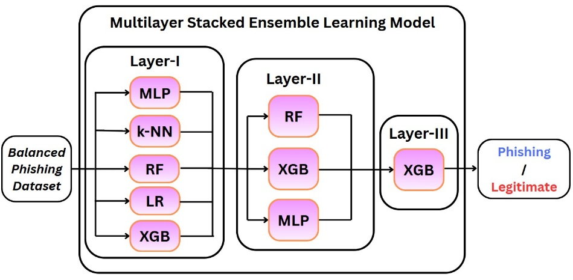
Fig. X. Architecture of proposed model by [27]
The system proposed by [20] utilized multiple ML algorithms on a different and much larger URL dataset [22]. It extracts several features and uses different algorithms to classify the URLs. The evaluation of this system too saw Random Forest outperforming the others, from which it can be inferred that the Random Forest ML algorithm adapts well with regards to scalability. Likewise, another study from [21] also highlights the superiority of RF with an accuracy of 97.3% on a more popular UCI dataset [23], while another from [26] using a semantic features URL dataset [25] saw RF outperforming 15 other ML algorithms to achieve a 99.06% accuracy. Thus, it can be inferred that RF is the best ML based algorithm for detecting phishing websites.
A study from [29] proposes an optimized stacking ensemble model for phishing detection using the UCI [23] Mendeley 2018 [25] and Mendeley 2020 [24] datasets. At first, RF & LightGBM had achieved the best accuracies, however, after applying Genetic Algorithm (GA)-based ensemble classifiers, there was a shift in performance rankings. GA-based Gradient Boosting achieved the highest accuracy on UCI (97.13%), while GA-based XGBoost did the same for Mendeley 2018 and 2020 (98.57% & 97.35%). These results emphasize that despite RF performing strongly, feature selection and algorithm tuning can yield superior results.
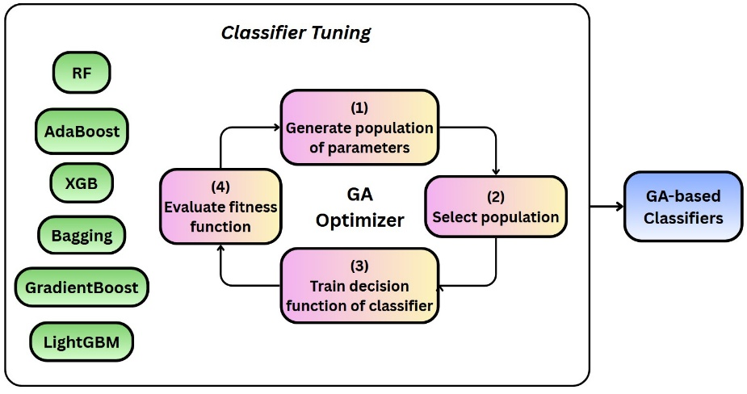
Fig. X. Application of GA to ML classifiers by [29]
An experimental study by [28] examined the impact of dataset balancing, hyperparameter tuning and feature selection on the performance of phishing detection. Utilizing the UCI [23] and Mendeley 2018 [25] datasets, each model was trained and tested twice, once with and without optimization. For the UCI, fine-tuning improved accuracy, while it remained the same for Mendeley 2018. From this, it can be inferred that proper optimization can maintain or even improve accuracy while considerably reducing computation cost.
One study [18] saw the proposal of a Rough Set Theory-Based Hybrid Feature Selection (RSTHFS) method that reduces the feature dependency in ML models. By combining Rough Set Theory (RST), Correlation-Based Feature Selection (CFS) and Cumulative Distribution Function (CDF), a feature cut-off is identified which reduces the number of features by 69.11% on 3 datasets [23], [24] and [25]. Evaluating the performance of CatBoost, LightGBM and RF, it was determined that RSTHFS was able to achieve similar accuracy while reducing runtime by 30%, thus highlighting the value of effective feature selection.
Deep Learning Based Systems (2.4.2)
The diverse and more sophisticated nature of URLs from phishing attacks over the last couple years have compelled researchers to turn to Deep Learning (DL)-based systems. In contrast to ML models, DL models are able to extract more complex patterns from data that would otherwise require extensive human defined features. This is especially powerful in the defense against zero-day phishing attacks.
The study from [30] evaluated and compared traditional ML models against a DL model called Convolutional Neural Network (CNN). The CNN utilized 3 dense layers with ReLU and sigmoid activation functions and was trained for 20 epochs. Evaluation of the CNN on 2 datasets [23], [24], saw it outperforming ML models with an accuracy of 99%.
Another study conducted by [31] analyzed and compared the performance of 3 DL models: CNN, LSTM which is an adaptive form of RNN and a LSTM-CNN hybrid system on the ISCX-URL2016 [22] dataset. Evaluation of the results saw CNN outperforming both LSTM and LSTM-CNN hybrid models by a difference of 3%, obtaining an accuracy of 99.2%.
While this shows CNNs perform tremendously for detecting phishing websites, a study from [32] found that a system employing a Recurrent Neural Network (RNN) with a Gated Recurrent Unit (GRU) managed to achieve a similar performance accuracy of 99.18%. The study also analyzed RNN on its own, which obtained an accuracy of only 74%, highlighting the power and importance of GRU.
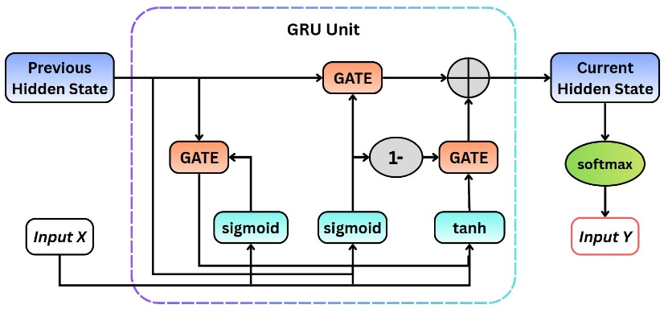
Fig. X. Illustration of the architecture of a GRU Unit used by [32]
Comparison of Related Work (2.5)
It is evident that traditional phishing detection systems such as list-based and heuristics-based systems are outdated due to their inability to be adaptive and handle zero-day attacks. As such, ML-based and DL-based systems are being considered as the next step and the hybrid framework proposed by this dissertation aims to improve upon that (refer to Section 3).
Table. X compares the studies discussed in terms of the datasets used, the proposed models and the accuracy achieved.
Study | Dataset | Model | Accuracy
[17] | PhishTank [9] | J48 Decision Tree | 93%
[19] | PhishTank [9] | Random Forest | 98.40%
[27] | UCI_2015 [23], Mendeley_2018 [25], Mendeley_2020 [24] | Multilayered Stacked Ensemble Model | 98.90%
[21] | UCI_2015 [23] | Random Forest | 97.30%
[26] | Mendeley_2018 [25] | Random Forest | 99.06%
[29] | UCI_2015 [23], Mendeley_2018 [25], Mendeley_2020 [24] | GA-based XGBoost | 98.57%
[30] | UCI_2015 [23], Mendeley_2018 [25] | CNN | 99%
[31] | ISCX-URL2016 [22] | CNN | 99.20%
[32] | Kaggle Dataset, PhishTank [9] | RNN-GRU | 99.18%
Table. X. Comparison of accuracy from related studies.
Methodology (3)
As illustrated in FIGURE NUM, the proposed phishing detection framework utilizes a hybrid approach employing a 1-Dimensional Convolutional Neural Network (1D-CNN) and a Bidirectional Gated Recurrent Unit (BiGRU) for classifying websites as phishing or legitimate. This 2-system approach is designed to utilize both the 1D-CNN’s ability to capture local lexical patterns and the BiGRU’s capability to model global sequential dependencies from the URL features, thus providing a novel, robust and effective phishing detection model.
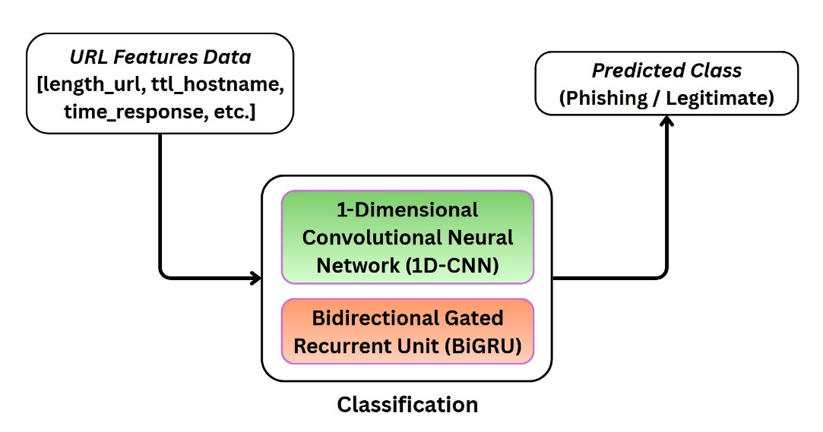
Fig. X. Architecture of Proposed Framework

Convolutional Neural Network (3.1)
The processing begins with the 1D-CNN, which functions to capture the lexical and structural patterns between the features of the URL. As stated in [33], CNNs make use of local connectivity, pooling and shared weights through multiple different layers to achieve this. In the proposed framework, several convolutional layers with varying filter sizes are employed to detect the local relations of features from one layer to the next. Each layer each is then followed by a non-linearity activation function and a max pooling layer to reduce dimensionality while still retaining important information.
Fig NUM displays the visual representation of the architectural structure of a 1D-CNN employed by [35].
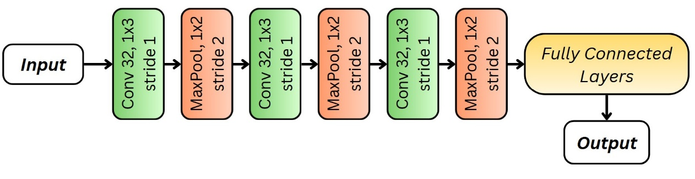
Fig. X. Illustration of 1D-CNN model by [35]

Bidirectional Gated Recurrent Unit (3.2)
The BiGRU layer extends the modelling capacity of the framework to further enhance performance. As per [35], a BiGRU model comprises of a forward directional and a backward directional GRU, which allows it to capture the contextual dependencies. [34] describes this as being able to capture elements from both the past and future in the data sequence. This bidirectional processing of the extracted feature maps from the 1D-CNN allows the proposed framework to ensure both the preceding and succeeding features in the URL influence the final outcome.
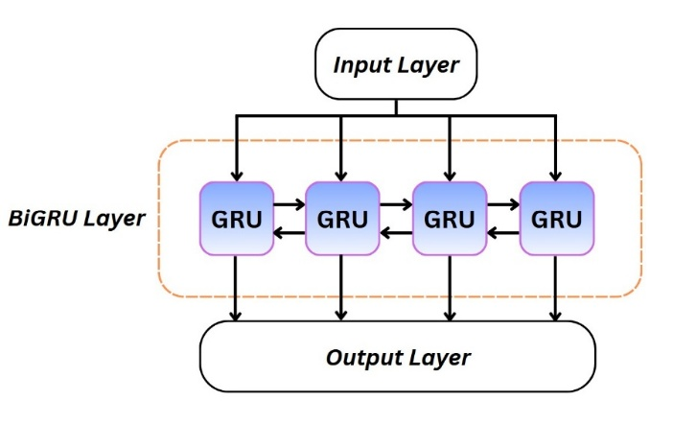
Fig. X. One BiGRU Layer as depicted by [35]
The output feature vectors are then passed through the CNN’s dense layers for obtaining the final classification. The employment of specific hyper parameters: sigmoid activation function in the output layer, adam optimizer and binary cross-entropy loss function ensures enhanced robustness and efficiency in obtaining a strong accuracy score with optimal performance.
Requirements Engineering (4)
This section shall cover all the necessary requirements that will have to be undertaken in order to ensure the framework is successfully developed. The requirements shall be prioritized based on the MoSCoW method, as displayed in Table. X.
Acronym | Priority | Priority Level
M | Must | Highest
S | Should | High
C | Could | Low
W | Won’t | Lowest
Table. X. Explanation of MoSCoW method of prioritization.
Functional Requirements (4.1)
ID | Requirement | Priority
FR.1 | Dataset Preprocessing | M
FR.1.1 | Datasets should be cleaned & normalized to remove redundancy and ensure better accuracy. | M
FR.1.2 | Datasets should be split into training and testing sets. | M
FR.1.2.1 | k-Fold Cross Validation should be employed for splitting the datasets. | S
FR.1.3 | Preprocessed datasets should be saved as separate files for easier access. | S
FR.2 | Feature Selection & Hyperparameter Tuning | S
FR.2.1 | Utilization of RSTFHS to significantly reduce the number of required features. | S
FR.2.2 | Hyper-parameter tuning using GridSearchCV for obtaining optimal model setups. | C
FR.3 | Implementation of Models | M
FR.3.1 | Training traditional ML models on the training set of our dataset. | M
FR.3.2 | Implementation and integration of 1D-CNN and BiGRU models, optimized with appropriate hyperparameters, to obtain desired hybrid framework. | M
FR.3.3 | Train the hybrid framework on the train set of the preprocessed datasets. | M
FR.3.4 | Test the trained framework on the test set of the datasets. | M
FR.4 | Performance Evaluation | M
FR.4.1 | From the model’s performance, generate the confusion matrix. | M
FR.4.2 | Calculate the empirical evaluation metrics using values derived from the confusion matrix. | M
FR.4.3 | Record the total training time for each model for analysis. | S
FR.4.4 | Identify which features influence the model’s predictions the most. | C
FR.5 | Comparative Analysis | M
FR.5.1 | Compare & analyze the performance metrics of ML models against that of our proposed hybrid framework. | M
FR.5.2 | Compare the performance of models across the two different datasets. | M
FR.5.3 | Compare the performance of models with and without feature selection & hyperparameter tuning. | S
FR.6 | Miscellaneous | C
FR.6.1 | Development of web app utilizing the hybrid framework. | C
FR.6.2 | Development of browser extension utilizing the hybrid framework. | C
Table. X. Table of Functional Requirements
Non-Functional Requirements (4.2)
ID | Requirement | Priority
NFR.1 | Hybrid framework must obtain a high accuracy of 80% or more. | M
NFR.2 | Access to models and datasets shall be restricted to the author and supervisor only. | S
NFR.3 | Datasets must be stored and processed locally. | M
NFR.4 | Throughput during testing phase should be tolerable. | S
Table. X. Table of Non-Functional Requirements
Hardware & Software Requirements (4.3)
This section covers the minimum requirements pertaining to hardware and software that are required to run this framework and experiment optimally.
ID | Component | Requirement
HR.1 | Processor (CPU) | Intel i5 or AMD Ryzen 5
HR.2 | Graphics Card (GPU) | Any NVIDIA GPU with 4+ GB VRAM
HR.3 | Memory (RAM) | 8 GB
HR.4 | Storage | 10 GB SSD for fast processing
SR.1 | Software | - Python 3.9+  - TensorFlow / Keras 2.12+  - NumPy 1.25+  - Pandas 2.0+  - Scikit-learn 1.3+  - Matplotlib
Table. X. Table of Hardware & Software Requirements
Evaluation (5)
Dataset (5.1)
For training and evaluating the proposed hybrid framework, two publicly available benchmark state-of-the-art datasets shall be employed, the UCI Phishing Websites Dataset [23] and the Mendeley 2020 Dataset [24]. Utilizing two datasets ensures that our framework performs consistently through evaluation across URL data of varying size and complexities. Both datasets comprise of previously extracted features from existing phishing and legitimate websites, thus eliminating the need for a feature extraction phase.
UCI Dataset (5.1.1)
The University of California Irvine Machine Learning Repository contains the Phishing Websites dataset which is one of the most widely used datasets in the field of phishing detection [23]. The dataset comprises 11,055 websites (4898 phishing, 6157 legitimate), each one distinguished by 30 different handcrafted features describing the website’s URL’s structural and lexical attributes. The 31st feature labels the website as phishing or legitimate, thus providing a clear binary classification problem.
Mendeley 2020 Dataset (5.1.2)
With contrast to the UCI dataset, the Mendeley 2020 Dataset comprises of 111 features extracted from 88,647 websites (30,647 phishing, 58,000 legitimate). The features extracted are more comprehensive encompassing the URL’s lexical properties (length, entropy), domain attributes (age, DNS) and network attributes (IP, ssl validity). The proposed hybrid framework based on deep learning models will surely benefit from the well-suited size and variety of this dataset.
Evaluation Metrics (5.2)
From testing the hybrid framework, 4 metrics can be obtained directly which are then utilized to generate the confusion matrix.
- True Positives (TP): The number of phishing websites correctly classified by the framework.
- True Negatives (TN): The number of legitimate websites correctly classified by the framework.
- False Positives (FP): The number of legitimate websites incorrectly classified as phishing by the framework.
- False Negatives (FN): The number of phishing websites incorrectly classified as legitimate by the framework.
 | Phishing | Legitimate
Phishing | TP | FP
Legitimate | FN | TN
Table. X. Confusion Matrix from testing the hybrid framework.
From the confusion matrix, we can derive several performance metrics that will precisely indicate where the framework stands. These metrics are based on the standard empirical classification metrics used to evaluate performance.
Accuracy (5.2.1)
Proportion of correctly classified websites among all predictions. It represents the overall performance of the hybrid framework in phishing detection in balanced datasets. However, both datasets that the hybrid framework will utilize are imbalanced with legitimate websites dominating. Thus, additional metrics are needed.
$$Accuracy = \frac{TP+TN}{TP+TN+FP+FN}$$
Precision (5.2.2)
Proportion of correctly classified phishing websites among all websites classified as phishing by the framework. A high precision indicates that the model produced very few false positives, thus preventing the unnecessary blacklisting of legitimate websites.
$$Precision = \frac{TP}{TP+ FP}$$
Recall (Sensitivity) (5.2.3)
Proportion of correctly classified phishing websites among all phishing websites. It can be seen as the accuracy of correctly predicting only phishing websites. A high recall indicates that the framework is able to detect and capture most phishing attacks, thus reducing the chances of letting real threats slip.
$$Recall = \frac{TP}{TP+FN}$$
F1-Score (5.2.4)
Represents the harmonic mean of the precision and recall. It balances FP and FN and is especially useful for imbalanced datasets.
$$F1-Score = 2 × \frac{Precision×Recall}{Precision+Recall}$$
Conclusions (6)
In conclusion, this dissertation proposes a hybrid deep learning framework to address an existing research gap in phishing websites detection. The proposed hybrid framework employs and integrates a 1-Dimensional Convolutional Neural Network (1D-CNN) with a Bidirectional Gated Recurrent Unit (BiGRU).
The research began with an extensive literature review (refer to Section 2), examining existing detection methodologies and datasets and highlighting their efficiency in detecting phishing websites. Through this, the scarcity of models combining temporal dependencies with lexical features extraction was made apparent (research gap). As such, an architecture for a hybrid deep learning framework (refer to Section 3) was conceived to address this research gap. This architecture sees the employment of a 1D-CNN to extract the local lexical features from the URLs of phishing websites, while the employment of a BiGRU component captures the temporal dependencies of these lexical URL tokens for better understanding the sequential relations between them. Together, these models form the end-to-end hybrid framework capable of detecting and identifying phishing websites.
To certify that, following the implementation, the framework shall be trained and tested on popular publicly available phishing datasets to ensure consistency, robustness and scalability. Empirical classification metrics shall be employed to evaluate the framework’s performance, to then be compared against existing ML models to identify its standing amongst them (refer to Section 5).
Looking forward, future work shall focus primarily on implementing the 1D-CNN and BiGRU models and integrating them to develop the proposed hybrid framework. This shall include training, hyperparameter tuning and feature extraction. As mentioned above, the framework will then be tested and compared to achieve our ultimate aim of developing a robust and adaptive phishing detection system for contributing to a more secure and safer cyberspace.

References
- Fedele, A., Tonin, M. and Valerio, M., 2024. Phishing attacks: An analysis of the victims’ characteristics based on administrative data. Economics Letters, 237, p.111663.
- Ali, M.M. and Mohd Zaharon, N.F., 2024. Phishing—A cyber fraud: The types, implications and governance. International Journal of Educational Reform, 33(1), pp.101-121.
- Sahingoz, O.K., Buber, E., Demir, O. and Diri, B., 2019. Machine learning based phishing detection from URLs. Expert Systems with Applications, 117, pp.345-357.
- Zieni, R., Massari, L. and Calzarossa, M.C., 2023. Phishing or not phishing? A survey on the detection of phishing websites. IEEE Access, 11, pp.18499-18519.
- Cao, Y., Han, W. and Le, Y., 2008, October. Anti-phishing based on automated individual white-list. In Proceedings of the 4th ACM workshop on Digital identity management (pp. 51-60).
- Jain, A.K. and Gupta, B.B., 2016. A novel approach to protect against phishing attacks at client side using auto-updated white-list. EURASIP Journal on Information Security, 2016(1), p.9.
- Guo, M., Wang, G., Hata, H. and Babar, M.A., 2021. Revenue maximizing markets for zero-day exploits. Autonomous Agents and Multi-Agent Systems, 35(2), p.36.
- Prakash, P., Kumar, M., Kompella, R.R. and Gupta, M., 2010, March. Phishnet: predictive blacklisting to detect phishing attacks. In 2010 Proceedings IEEE INFOCOM (pp. 1-5). IEEE
- PhishTank, n.d. PhishTank: a free community site for submitting and verifying suspected phishing websites and emails [online]. Available at: https://www.phishtank.com/ (Accessed: 17 October 2025).
- Google Safe Browsing, n.d. Google Safe Browsing: keeping over five billion devices safer [online]. Available at: https://safebrowsing.google.com/ (Accessed: 17 October 2025).
- da Silva, C.M.R., Feitosa, E.L. and Garcia, V.C., 2020. Heuristic-based strategy for Phishing prediction: A survey of URL-based approach. Computers & Security, 88, p.101613.
- Zhang, Y., Hong, J.I. and Cranor, L.F., 2007, May. Cantina: a content-based approach to detecting phishing web sites. In Proceedings of the 16th international conference on World Wide Web (pp. 639-648).
- Xiang, G., Hong, J., Rose, C.P. and Cranor, L., 2011. Cantina+ a feature-rich machine learning framework for detecting phishing web sites. ACM Transactions on Information and System Security (TISSEC), 14(2), pp.1-28.
- Jain, A.K. and Gupta, B.B., 2017. Phishing detection: analysis of visual similarity based approaches. Security and Communication Networks, 2017(1), p.5421046.
- Wang, M., Song, L., Li, L., Zhu, Y. and Li, J., 2024. Phishing webpage detection based on global and local visual similarity. Expert Systems with Applications, 252, p.124120.
- Wei, Y. and Sekiya, Y., 2022. Sufficiency of ensemble machine learning methods for phishing websites detection. IEEE Access, 10, pp.124103-124113.
- James, J., Sandhya, L. and Thomas, C., 2013, December. Detection of phishing URLs using machine learning techniques. In 2013 international conference on control communication and computing (ICCC) (pp. 304-309). IEEE.
- Setu, J.H., Halder, N., Islam, A. and Amin, M.A., 2025. RSTHFS: A Rough Set Theory-Based Hybrid Feature Selection Method for Phishing Website Classification. IEEE Access, 13, pp.68820-68830
- Tyagi, I., Shad, J., Sharma, S., Gaur, S. and Kaur, G., 2018, February. A novel machine learning approach to detect phishing websites. In 2018 5th International conference on signal processing and integrated networks (SPIN) (pp. 425-430). IEEE.
- Gupta, B.B., Yadav, K., Razzak, I., Psannis, K., Castiglione, A. and Chang, X., 2021. A novel approach for phishing URLs detection using lexical based machine learning in a real-time environment. Computer Communications, 175, pp.47-57.
- Alnemari, S. and Alshammari, M., 2023. Detecting phishing domains using machine learning. Applied Sciences, 13(8), p.4649.
- Canadian Institute for Cybersecurity, 2016. URL dataset (ISCX-URL2016) [dataset]. Available at: https://www.unb.ca/cic/datasets/url-2016.html (Accessed: 18 October 2025)
- Mohammad, R. and McCluskey, L., 2012. Phishing Websites. UCI Machine Learning Repository. Available at: https://doi.org/10.24432/C51W2X (Accessed: 19 October 2025)
- Vrbančič, G., 2020. Phishing Websites Dataset. Mendeley Data, V1. doi: 10.17632/72ptz43s9v. Available at: https://doi.org/10.17632/72ptz43s9v.1 (Accessed: 19 October 2025)
- Tan, C.L., 2018. Phishing dataset for machine learning: Feature evaluation. Mendeley Data, 1(8)., V1. doi: 10.17632/h3cgnj8hft.1 Available at: https://doi.org/10.17632/h3cgnj8hft.1 (Accessed: 19 October 2025)
- Almomani, A., Alauthman, M., Shatnawi, M.T., Alweshah, M., Alrosan, A., Alomoush, W. and Gupta, B.B., 2022. Phishing website detection with semantic features based on machine learning classifiers: a comparative study. International Journal on Semantic Web and Information Systems (IJSWIS), 18(1), pp.1-24.
- Kalabarige, L.R., Rao, R.S., Abraham, A. and Gabralla, L.A., 2022. Multilayer stacked ensemble learning model to detect phishing websites. Ieee Access, 10, pp.79543-79552.
- Abdul Samad, S.R., Balasubaramanian, S., Al-Kaabi, A.S., Sharma, B., Chowdhury, S., Mehbodniya, A., Webber, J.L. and Bostani, A., 2023. Analysis of the performance impact of fine-tuned machine learning model for phishing URL detection. Electronics, 12(7), p.1642.
- Al-Sarem, M., Saeed, F., Al-Mekhlafi, Z.G., Mohammed, B.A., Al-Hadhrami, T., Alshammari, M.T., Alreshidi, A. and Alshammari, T.S., 2021. An optimized stacking ensemble model for phishing websites detection. Electronics, 10(11), p.1285.
- Almujahid, N.F., Haq, M.A. and Alshehri, M., 2024. Comparative evaluation of machine learning algorithms for phishing site detection. PeerJ Computer Science, 10, p.e2131.
- Alshingiti, Z., Alaqel, R., Al-Muhtadi, J., Haq, Q.E.U., Saleem, K. and Faheem, M.H., 2023. A deep learning-based phishing detection system using CNN, LSTM, and LSTM-CNN. Electronics, 12(1), p.232.
- Tang, L. and Mahmoud, Q.H., 2021. A deep learning-based framework for phishing website detection. IEEe Access, 10, pp.1509-1521.
- LeCun, Y., Bengio, Y. and Hinton, G., 2015. Deep learning. nature, 521(7553), pp.436-444.
- She, D. and Jia, M., 2021. A BiGRU method for remaining useful life prediction of machinery. Measurement, 167, p.108277.
- Joolee, J.B., Uddin, M.A. and Jeon, S., 2022. Deep multi-model fusion network based real object tactile understanding from haptic data. Applied Intelligence, 52(14), pp.16605-16620.
- Anti-Phishing Working Group, 2025. Phishing Activity Trends Report – 2nd Quarter 2025. Cambridge, MA: Anti-Phishing Working Group. Available at: https://docs.apwg.org/reports/apwg_trends_report_q2_2025.pdf (Accessed: 16 October 2025)

Project Management (A)
In order to ensure the research is consistent with the objectives and is completed on time without being rushed, proper planning and organization is required from the start until the end. This section outlines the scope and planning of the projects along with the placement of milestones to ensure progress is executed smoothly. Moreover, the section shall also contain an analysis of possible risks that can be encountered during the project, and ways to mitigate them.
Project Scope (A.1)
This research aims to address the current limitation of phishing websites detection systems, specifically the lack of existing systems that combine lexical feature extraction from phishing URLs with temporal sequential dependencies to understand patterns and relations. To overcome this gap, this project proposes an end-to-end hybrid deep learning framework, integrating a 1-Dimensional Convolutional Neural Network (1D-CNN) for extracting lexical features, with a Bidirectional Gated Recurrent Unit (BiGRU) for capturing sequential dependencies.
The project scope can be divided into the following key tasks for its development:
- Preprocessing publicly available phishing datasets.
- Normalizing data for better training compatibility.
- Implementing the 1D-CNN to extract lexical features.
- Integrating a BiGRU model to extract temporal features.
- Combining both models to form the hybrid framework.
- Evaluating the performance of the framework using empirical metrics.
- Comparing the performance of the framework against existing ML based systems.
- Documenting possible risks that can be encountered and providing mitigation strategies.

Project Deliverables (A.2)
The project is divided into 5 deliverables, each of which has to be submitted before their specific deadlines. It is imperative for all tasks pertaining to each deliverable to be completed in an organized and timely fashion for smooth delivery. The deliverables are described below.
Project Proposal and Research Document (Semester 1) (A.2.1)
The first deliverable is the research document establishing the foundation of the project by highlighting a brief overview of the study and the preparation done for it. It shall state the project’s aim and objectives concisely along with the background behind the motivation of the project. A comprehensive literature review of existing studies and research in the field of phishing detection systems shall be conducted. The methodology behind the project’s proposed framework shall be established, along with the datasets and empirical metrics on which it will be evaluated. This report will also present a work plan with milestones, possible risks associated with the project and provide strategies to mitigate them, as well as address any relevant professional, legal, ethical and social issues.
5-Minute Feasibility Video (Semester 1) (A.2.2)
The second deliverable is a short 5 minute video and presentation explaining the work done behind the overview and preparation for this project as well as an explanation of the feasibility of the proposed 1D-CNN-BiGRU hybrid framework’s completion within planned timeframes.
Dissertation Report (Semester 2) (A.2.3)
The third deliverable is the final comprehensive dissertation, which documents the complete lifecycle of the project’s implementation including detailed descriptions of the methodology, systems and algorithms. It shall also include the detailed evaluation process, along with an in-depth analysis of the performance evaluated against other models to establish its standing and contributions.
Project Management Repository (Semester 2) (A.2.4)
The fourth deliverable is a project management repository containing all project related materials including: relevant research papers, datasets, diagrams and figures, logbooks, documentations and source code files. The repository shall be maintained and updated throughout the development lifecycle in order to provide traceability as well as act as evidence of work.
Q&A Session (Semester 2) (A.2.5)
The final deliverable is a Q&A session between the author of this dissertation and the supervisor with an additional marker. It is here that the author’s knowledge and capabilities on phishing detection systems with regards to the project’s design and framework implementation will be tested.

Project Plan (A.3)
The project plan serves as a structured timeline depicting the execution of every task from the beginning of the project’s preliminary research, through to the end of every necessary deliverable. It highlights the important tasks, milestones and deadlines that need to be met for smooth completion of the project. The plan is divided into two semesters, each corresponding to the two main deliverables required. The Gantt charts shown in Figure. X and Figure. X depicts the planning and listing of tasks required for completion of each deliverable for each semester in time phased manner.
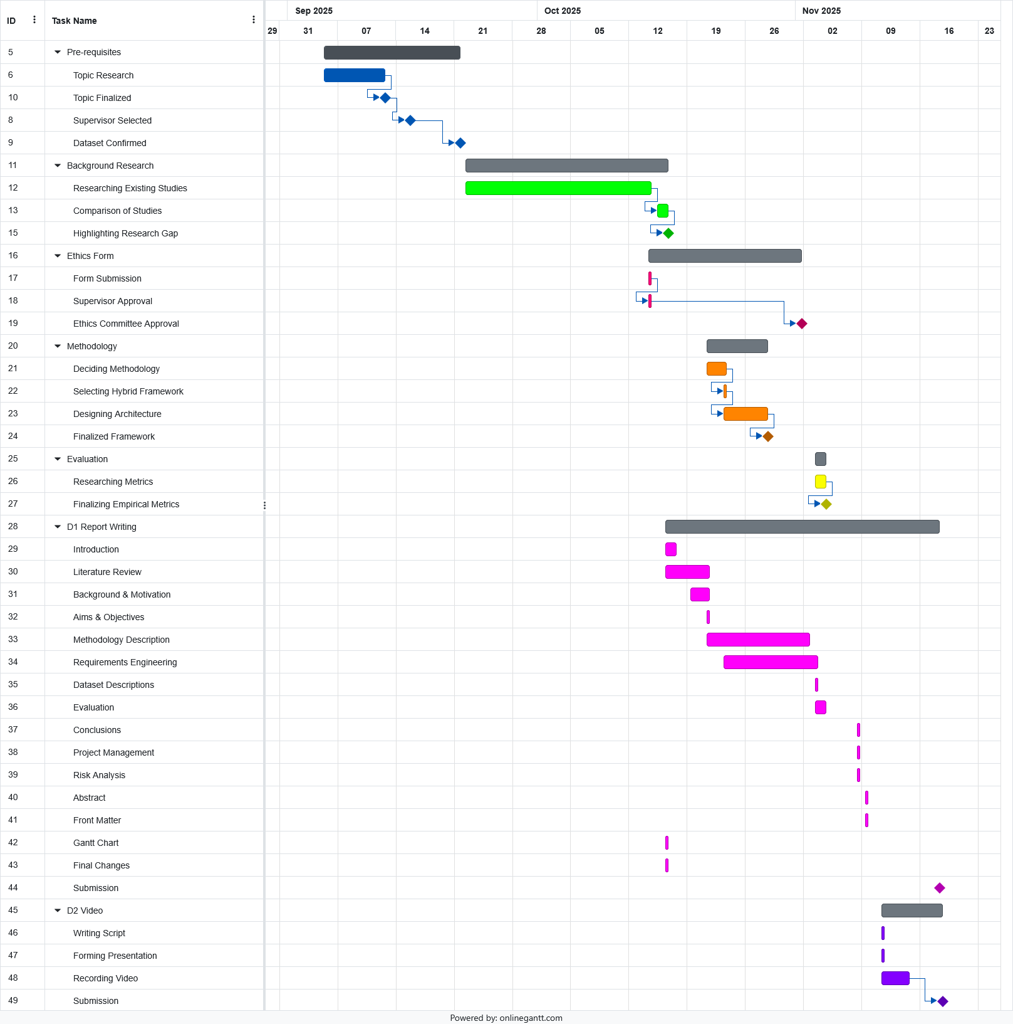
Fig.X. Project Timeline for Semester 1

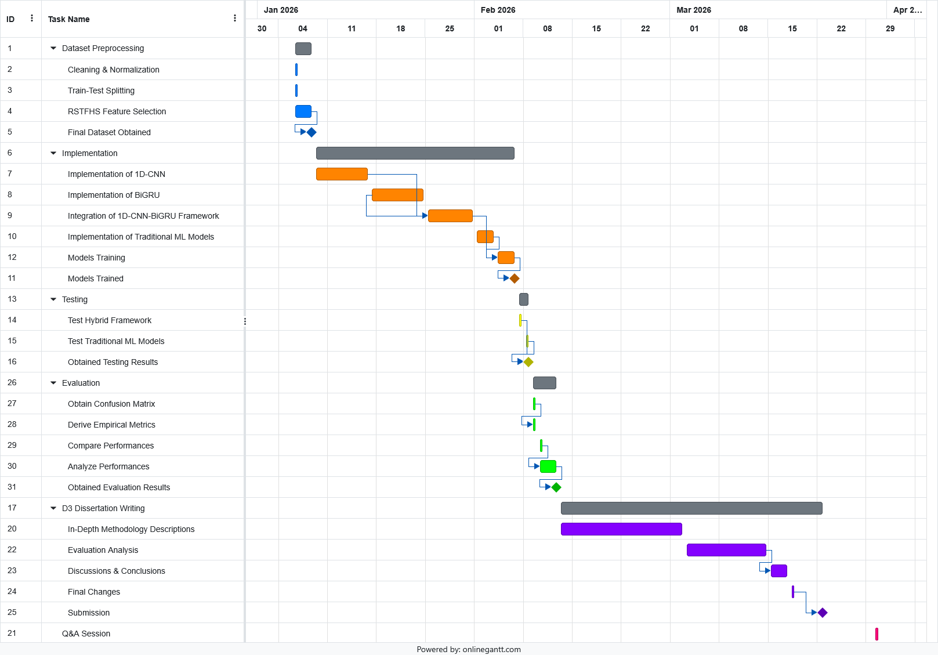
Fig.X. Project Timeline for Semester 2
Risk Analysis (A.4)
This section shall go over the possible risks that can be encountered during the development of the project. It is imperative that all possible risks are conceptualized as part of risk analysis so as to ensure that the project proceeds on schedule without any unforeseen complications.
Table. X outlines the most probable risks, their likelihood and impact, as well as a possible strategy to mitigate or eliminate it. The likelihood can be classified as Very Likely, Likely, Possible and Unlikely. Impact can be classified as Very High, High, Medium and Low.
Risk | Likelihood | Impact | Mitigation Strategy
Low performance of hybrid framework. | Likely | High | Further hyper-parameter tuning, ensuring model is properly coded
Hybrid framework does not outperform other ML models. | Very Likely | High | Extensive hyper-parameter tuning.
Overfitting During Training | Likely | Medium | Implement cross validation, dropout or early stopping.
Inconsistent Evaluation Results. | Possible | High | Conduct multiple test runs and ensure consistent implementation of empirical metrics.
Data Corruption / Loss of Progress | Unlikely | Very High | Make regular copies and backups.
System Failure | Unlikely | Very High | Make backup saves to cloud storage.
Insufficient Hardware Capabilities & Resources | Unlikely | High | Utilize cloud-based environments such as Google Colab.
Time Constraints | Unlikely | Medium | Adhere to the planned timeline in the Gantt charts.
Bugs in developed code | Likely | Medium | Debugging and testing every feature in increments.
Table. X. Risk Analysis Table

Professional, Legal, Ethical and Social Issues (B)

Professional Issues (B.1)

Legal Issues (B.2)

Ethical Issues (B.3)

Social Issues (B.4)

